# Concept

Pet ID provides a global, blockchain-based proof of identity infrastructure for pets, offering secure and universally accessible identity verification solutions for everyday pet owners.

# Mission

**“Empowering Pet Owners Worldwide”:** Pet ID strives to simplify and secure pet ownership with a user-friendly digital platform that leverages blockchain technology. By focusing on intuitive design and robust privacy measures, we aim to make advanced Web3 technologies accessible to all pet owners, enhancing their ability to manage their pets’ identities and health records securely and efficiently. Our commitment is to reduce bureaucratic hurdles in pet ownership and promote the welfare and safety of pets globally.

# Vision

**“A Global Standard for Pet Management”**: Our vision is to establish Pet ID as the worldwide standard for pet identity and health management. By integrating innovative technologies like NFC, blockchain, and encrypted data we envision a future where every pet’s vital information is accessible in a secure, private manner to those who need it. Our platform will serve as a universal solution that enhances the lives of pets and their owners, bridging gaps across nations and communities and creating a seamless, secure network of pet care.

# Current Need

Dog owners around the world face the challenge of navigating fragmented pet identification systems that vary significantly by region. These systems are often not interoperable, creating hurdles for pet owners who need to comply with different regional regulations, especially when traveling or relocating. Such fragmentation complicates the process of maintaining up-to-date vaccination records and accessing recovery services in case pets go missing.

The Pet ID app aims to streamline this global issue by offering a universal, blockchain-based platform for pet identification. This innovative solution facilitates compliance with various international regulations, providing a consistent and secure approach to managing pet identities and records across borders. By centralizing pet information, the Pet ID app not only simplifies the management process for pet owners but also enhances the reliability of data for veterinarians and regulatory bodies.

In addition to addressing identification issues, the app is poised to assist pet owners with upcoming regulatory changes. For instance, starting in late September 2023, Spain's new Animal Welfare Law requires all dog owners to have mandatory civil liability insurance that covers potential damages caused by their pets. Similarly, in the United States, new pet travel regulations will take effect on August 1, 2024, which includes features like the DogBot to help owners easily understand and comply with these evolving rules, ensuring they can provide the necessary care and protection for their pets no matter where they are.

Here’s how Pet ID addresses specific regional use cases (challenge/solution):

| European Union (Spain) | Asia (Korea) | Mexico City (Latin America) | USA (North America) |
| --- | --- | --- | --- |
| Each autonomous community in Spain might have slightly varying requirements for pet identification despite overarching EU standards. | Strict public regulations for pet identification, including microchips and tags, alongside penalties for non-compliance. | A need for a centralized record to manage vaccinations, sterilizations, and owner responsibilities akin to human population registration. | Variability in microchipping practices, costs, and the management of pet recovery databases. |
| Pet ID standardizes these processes by offering a single platform where all information, from health standards to local administrative nuances, is accessible and verifiable on-chain. | Pet ID ensures easy registration, updates, and compliance tracking directly through the app, reducing the risk of fines and improving the ease of following local laws. | Pet ID acts as a digital version of the Registro Único de Animales de Compañía (RUAC), streamlining access to government services and enhancing response to animal welfare issues. | Pet ID provides a one-time, cost-effective solution for microchip registration that includes lifelong management and access to a recovery database, eliminating the need for multiple registrations and fees. |

# Why using blockchain?

Blockchain is crucial for Pet IDs as it ensures immutable, secure data storage and global interoperability, unlike centralized systems which can be fragmented and inconsistent across borders.

Pet ID is a comprehensive global platform designed to provide a decentralized, secure, and universally accessible pet identity system using blockchain technology. This project aims to address the fragmented nature of current pet identification systems by offering a standardized, interoperable solution that caters to pet owners, veterinarians, government bodies, and insurance companies worldwide.

Problems Addressed:

1. **Global Mobility and Compliance:** With increasing global mobility, pet owners require a universally accepted system to prove their pets' identities and health statuses. Pet ID streamlines compliance with diverse international regulations related to pet travel and import/export requirements.
2. **Emergency and Health Services Coordination:** Quick access to a pet’s medical history and owner details is vital during emergencies or when accessing specialized veterinary services. Pet ID facilitates instant, secure access to such information, enhancing response times and care quality.
3. **Loss Mitigation:** Losing a pet can be traumatic. Pet ID's robust, tamper-proof system will improve recovery rates through a universally recognized identification that is difficult to alter.
4. **Responsibility and Legal Consequences for Irresponsible Ownership:** The system aids in addressing abandonment and tracks legal responsibilities, potentially reducing pet suffering by holding owners accountable.
5. **Data Privacy in Pet Management:** With growing data privacy concerns, pet owners demand solutions that protect their information. Pet ID, integrated with Fhenix technology, ensures that data is encrypted, maintaining privacy and accessibility only to authorized parties.

To be addressed:

**Regulatory Compliance:**

* Assists pet owners in adhering to local regulations by streamlining the process of registering pets and maintaining up-to-date records on vaccinations and other legal requirements.

**Integration with Services:**

* Connects seamlessly with various pet-related services, including insurance, veterinary care, and local pet services, offering convenience and improving the quality of pet care.
* Social network for pet owners

**Integration with Smart Devices and IoT:**

* As homes and devices become smarter and more integrated, there is potential to link pets more closely with smart home ecosystems for monitoring, feeding, and even medical care. Pet ID can serve as the secure backbone for integrating pets into these systems, ensuring data privacy and reliability.

# Key components

**NFC Integration:** An NFC-compatible tag or bracelet stores the pet’s blockchain ID. This tag can be scanned by smartphones or specialized devices, providing instant access to the pet’s profile without needing an internet connection.

**Universal Pet ID:** Every pet is assigned a unique digital identifier via NFC scanning. This identifier is linked to a digital passport that contains vital information such as the pet’s breed, age, medical history, vaccination records, and owner details stored in Fhenix.

**ID Minting:** Owners can create a digital identity for their pets by minting a unique token on the blockchain. This process involves filling in the form data and linking it to a secure digital token that acts as the pet’s identity.

**Social Rewards System:** (Not included in the demo) The platform incentivizes responsible pet ownership through a social rewards system. Owners who regularly update their pets' health records, participate in community events, or contribute to pet welfare programs earn discounts on services.

**Access to Medical and Travel Records:** Instant, secure access to a pet’s medical and travel records facilitates easy compliance with international travel regulations and emergency medical care. This system uses smart contracts to ensure that only authorized parties can access specific data points.

**Data Security and Privacy:** Leveraging blockchain's inherent security features, all data stored on the Pet ID platform is encrypted in Fhenix and only accessible through private keys held by the pet owner or authorized entities.

**Decentralized Application (DApp) Interface:** The platform includes a user-friendly DApp that allows pet owners to manage their pets’ identities, update health records, and potentially, claim rewards, and even register for community events.

**Global Accessibility:** The platform is built to be globally accessible, overcoming language barriers and local regulation differences. It aims to standardize pet ID protocols across borders, making international travel and relocation smoother for pet owners.

# Set up process

1. Scan NFC: Begin by scanning the NFC-bracelet acquired from PetID.
2. Identify yourself through Dynamic in Pet ID app. This step secures your access and ensures that all interactions are securely logged on the blockchain.
3. Fill in Data: Enter or update yours and your pet’s details, including medical history, vaccination records, and any other relevant information. This data is crucial for maintaining an up-to-date profile for your pet.
4. Upload a Pic: Upload a current photograph of your pet. This photo will be associated with your pet’s digital profile and helps with visual identification.
5. Mint an NFT: Finalize the process by minting an NFT. This NFT represents your pet’s digital identity on the blockchain, ensuring that all the information is tamper-proof and permanently linked to your pet.

# ID dapp

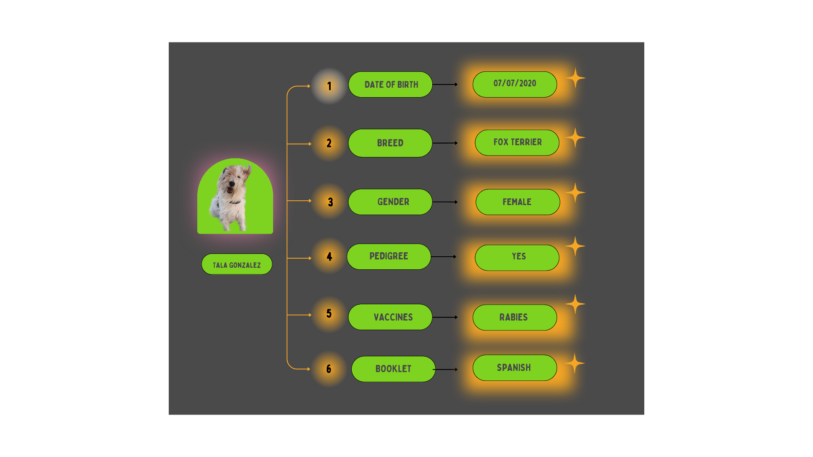

The Pet ID Dapp allows pet owners who have already minted their pet’s ID to securely access, modify, or upload new information about their pet. This decentralized application utilizes blockchain technology to ensure that all data associated with the pet’s ID is kept secure and up-to-date.

### **Daily Use of Pet ID Dapp**

1. **NFC Scanning:**
   * The NFC bracelet can be scanned using any NFC-enabled smartphone or device. This scan retrieves the pet’s unique ID from the blockchain, granting instant access to the pet’s profile.
2. **Viewing Pet Information:**
   * Upon scanning, the individual is redirected to a secure webpage displaying the pet’s information as permitted by the owner. This might include contact details, medical history, or other pertinent information.
3. **Updating Information:**
   * Pet owners can update their pet’s data on the Pet ID platform as necessary. All changes are immediately reflected and securely updated on the blockchain, ensuring that the information available via NFC scan is always current.
4. **Lost and Found Mode:**
   * In the event that a pet goes missing, the owner can activate a "Lost" mode via their Pet ID account. This mode updates the information displayed when the bracelet is scanned to include how to contact the owner or a designated emergency contact.

### **Security and Privacy Features**

1. **Access Controls:**
   * Owners have the ability to set privacy controls that dictate what information can be accessed through the NFC scan. For instance, they might allow only veterinary clinics to view the pet’s medical history, or they could restrict access to certain details unless they choose to share them explicitly.
2. **Encryption and Security:**
   * All data transmitted from the NFC bracelet and stored on the blockchain is encrypted using the Fhenix protocol. This ensures that sensitive information is securely managed and accessible only to authorized parties.

### **Lost and Found Process**

1. **Scanning the NFC Bracelet:**
   * If a pet is found, the finder can begin by scanning the pet’s NFC bracelet with an NFC-enabled device.
2. **Accessing Information:**
   * The scan directs the finder to a webpage that displays information set by the owner to be accessible in public or emergency scenarios. This typically includes contact details and instructions on how to return the pet safely.
3. **Contacting the Owner:**
   * The finder can use the provided contact information to inform the owner of the pet’s whereabouts.
4. **Updating Pet Status:**
   * Once the pet is found, the owner can update the status on the Pet ID platform to reflect that the pet is no longer lost. This process ensures a quick reunion between the pet and its owner and maintains the integrity and usefulness of the information on the blockchain.

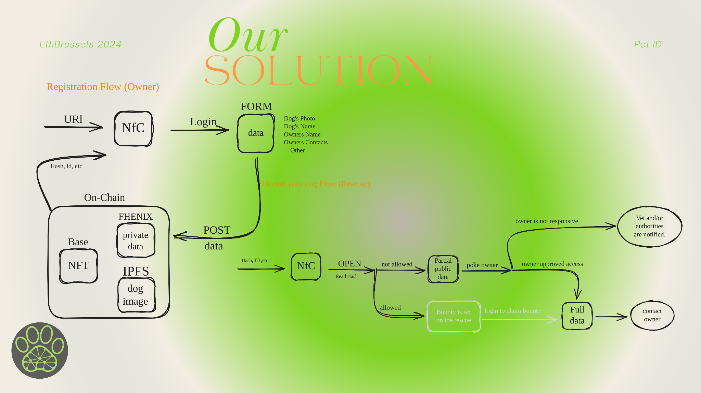

# Technology used

- Log in to dapp via dynamic

- React as frontend

- IFPS to store the images of pets

- Fhenix to encrypt and store data on-chain

- NFC technology for user accesibility

- Solidity for the smart contracts, Javascript and Typescript for the rest

- Blockscout to explore the Fhenix network and verify our smart contract

# Roadmap integration

Pet ID is committed to expanding its role as a leading solution for pet identification globally. Our roadmap focuses on innovation, security, and enhancing user accessibility to meet the evolving needs of pet owners and regulatory bodies worldwide.

To-do-list: Integration with Existing Systems: Pet ID is designed to integrate seamlessly with existing pet registration databases, veterinary practice management software, and government regulatory frameworks to ensure broad adoption and functionality.

**2024 - Q1 & Q2:**

* **Launch of NFC-Enabled Tags:**
  + Roll out NFC-enabled bracelets and tags that link directly to a pet’s digital profile on Pet ID.
* **Multi-Language Support:**
  + Introduce platform support for multiple languages to increase accessibility for non-English speaking users globally.

**2024 - Q3 & Q4:**

* **Expansion of Health Record Features:**
  + Enhance the health records module to include automated reminders for vaccinations and vet appointments.
* **Partnerships with International Pet Services:**
  + Establish partnerships with global pet service providers to offer seamless services directly through the Pet ID platform.

**2025 - Q1 & Q2:**

* **Smart Contract Functionality for Automatic Compliance:**
  + Integrate smart contracts to automate compliance-related tasks, such as renewals of licenses and registrations.

**2025 - Q3 & Q4:**

* **Geofencing Alerts:**
  + Introduce geofencing capabilities to alert owners if their pet leaves a designated safe area.
* **Advanced Analytics for Pet Health:**
  + Develop predictive analytics features to offer insights into pet health trends and potential medical issues.

**2026 and Beyond:**

* **Global Regulatory Framework Integration:**
  + Work with international bodies to integrate Pet ID as a standard practice in pet management globally.
* **Blockchain Innovations:**
  + Continue to explore and implement cutting-edge blockchain technologies to further enhance the security and functionality of the Pet ID ecosystem.

# FAQs for Pet ID:

1. What is Pet ID?

Pet ID is a digital identity platform for pets that uses blockchain technology to create a unique, verifiable identity for each pet, allowing for secure and accessible records management globally.

2. How do I create a Pet ID for my dog?

To create a Pet ID, simply register on our platform, fill in the required information about your pet, and mint a digital ID as an NFT. This NFT will serve as your pet’s unique identity on the blockchain.

3. Is there a fee to create a Pet ID?

There may be a small blockchain transaction fee (gas fee) required to mint your pet’s ID as an NFT. Any additional costs will be clearly outlined during the registration process.

4. How can Pet ID benefit my pet?

Pet ID provides a secure, immutable record of your pet’s identity and health information, which can be crucial for veterinary care, breeding, travel, and in case your pet gets lost.

5. Who can access my pet’s information?

You control who can access your pet’s information through Pet ID. You can grant or revoke access to veterinarians, pet services, or other entities as needed.

6. What information is stored in my pet’s Pet ID?

The Pet ID can store various information such as your pet’s name, breed, age, medical history, vaccination records, and microchip number. You can choose what information to include.

7. Can I update my pet’s Pet ID information?

Yes, you can update the information on your pet’s ID as needed. This is especially useful for updating medical records or changing ownership details.

8. How secure is Pet ID?

Pet ID uses blockchain technology, ensuring that all data is encrypted and stored securely. Only authorized users can access or modify the data.

9. What happens if I lose my pet?

If your pet is lost, you can update its Pet ID status to “Lost.” This can alert the Pet ID community, you’ll be able to set a bounty and local services to help in locating your pet.

10. Is Pet ID available internationally?

Yes, Pet ID is designed to be globally accessible, making it easier to manage pet information when traveling or relocating to another country.

# Form info

DOG INFO

NAME: ________

1. DATE OF BIRTH
2. BREED
3. GENDER
4. PEDIGREE (Yes/No)
5. VACCINES
6. BOOKLET

OWNERS INFO

1. NAME
2. ADDRESS
3. TELEPHONE NUMBER
4. EMAIL ADDRESS

CERTIFICATIONS

1. Pedigree
2. Vet contact

SOCIALS

Connect your socials

OUTPUTS: REGISTRATION NUMBER